

**NEW WEEKLY JOB POSTINGS FROM   
HELP WANTED ONLINE  
Office of Research**

**Week Ending January 28th, 2023:   
January Weekly New Ads Average Almost 1,000 New Ads Above December.**WETHERSFIELD, February 3rd, 2023 – During the week ending January 28th, there were 7,604 new postings, up 1,031 new ads from a week ago. This over-the-week change follows two weeks that had total new ad counts revised down. The weeks ending January 14th and 21st were respectively revised down from 9,188 to 7,163 and 6,637 to 6,573. As a result, the graph below illustrates a much less pronounced rebound from the December 2022 new ad dip than was previously reported. The largest statewide industry over-the-week increases occurred in Manufacturing (+337 new ads), Health Care & Social Assistance (+177 new ads), and Retail Trade (+89 new ads). Employers with the largest increases over the week include Raytheon (+234 new ads), Yale-New Haven Health System (+188 new ads), and KPMG (+71 new ads). The occupations with the largest over-the-week increases are Retail Salespersons (+74 new ads), Mechanical Engineers (+38 new ads), and Supervisors of Retail Sales Workers (+32 new ads). The revised data show that the four weeks ending in January 2023 averaged 6,833 new ads per week, which is almost 1,000 ads higher than December 2022, which averaged 5,817 ads per week.   
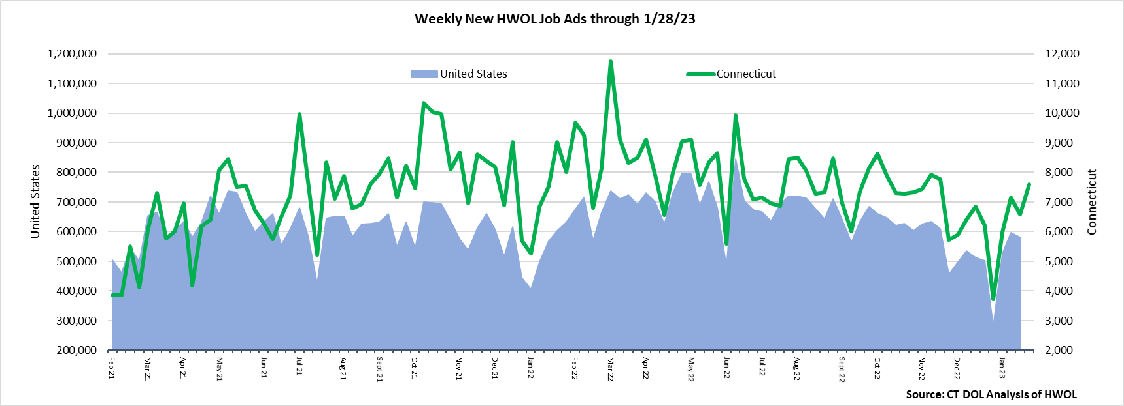  
**Industries** with the most new postings include Health Care & Social Assistance, Manufacturing, and Retail Trade.

**Occupations** with the most new postings include Registered Nurses, Retail Salespersons, and Supervisors of Retail Sales Workers.

**Employers** with the most new postings include Raytheon, Yale-New Haven Health System, and the State of Connecticut.

**The three industries with the most new job postings were:**

* **Health Care & Social Assistance** (1,773 new postings, +10% over the week)
* **Manufacturing** (897 new postings, +60% over the week)
* **Retail Trade** (635 new postings, +14% over the week)

   
 During the week ending January 28th, 2023, the 1,031 new ad increase is the net result of a combined 1,223 ad increase among 15 industries and a combined 192 ad decrease among five industries. The largest industry increases over the week were Manufacturing (+337 new ads), Health Care & Social Assistance (+177 new ads), and Retail Trade (+89 new ads). Educational Services (-90 new ads) had the largest new ad decrease. The three Manufacturing industry employers with the most ads were Raytheon (312 new ads), General Dynamics (59 new ads), and Lockheed Martin   
(15 new ads). The three Health Care industry employers with the most ads were Yale-New Haven Health System   
(222 new ads), Community Health Center (98 new ads), and Saint Francis Health System (69 new ads).  
  
 For more information on total job ads by industry for Connecticut and its labor market areas, see the monthly report available here: <https://www1.ctdol.state.ct.us/lmi/hwol.asp>

**New Job Postings by Occupation** 

**The occupations with the most new postings were:**

* Registered Nurses (442 new postings, +6% over the week)
* Retail Salespersons (219 new postings, +51% over the week)
* Supervisors of Retail Sales Workers (174 new postings, +23% over the week)

**Employers with the Most New Job Postings** Employers with the most new job postings during the week were mostly within Health Care & Social Assistance, Manufacturing, and Retail Trade. The 25 employers shown above combined account for 1,718 job ads or 22 percent of all new ads. The largest over-the-week increases occurred at Raytheon (+234 new ads) and Yale-New Haven Health System (+188 new ads). The largest occupational increase at Raytheon was Mechanical Engineers (+35 new ads) and at Yale-New Haven Health System, the largest increase was Registered Nurses (+40 new ads).  
  
**What is HWOL?**The **Conference Board Help Wanted Online**® Data Series (HWOL) measures the number of new, first-time Online job postings and jobs reposted from the previous month for over 16,000 Internet job boards, corporate boards, and smaller job sites that serve niche markets and smaller geographic areas. To view more HWOL data, go to: <https://www1.ctdol.state.ct.us/lmi/hwol.asp>